1. Create a function to perform basic arithmetic operations that includes addition, subtraction, multiplication and division on a string number (e.g. "12 + 24" or "23 - 21" or "12 // 12" or "12 * 21").

Here, we have 1 followed by a space, operator followed by another space and 2. For the challenge, we are going to have only two numbers between 1 valid operator. The return value should be a number.

eval() is not allowed. In case of division, whenever the second number equals "0" return -1.

For example:

"15 // 0" ➞ -1

**Examples**

arithmetic_operation("12 + 12") ➞ 24 // 12 + 12 = 24

arithmetic_operation("12 - 12") ➞ 24 // 12 - 12 = 0

arithmetic_operation("12 * 12") ➞ 144 // 12 * 12 = 144

arithmetic_operation("12 // 0") ➞ -1 // 12 / 0 = -1

**Ans:** 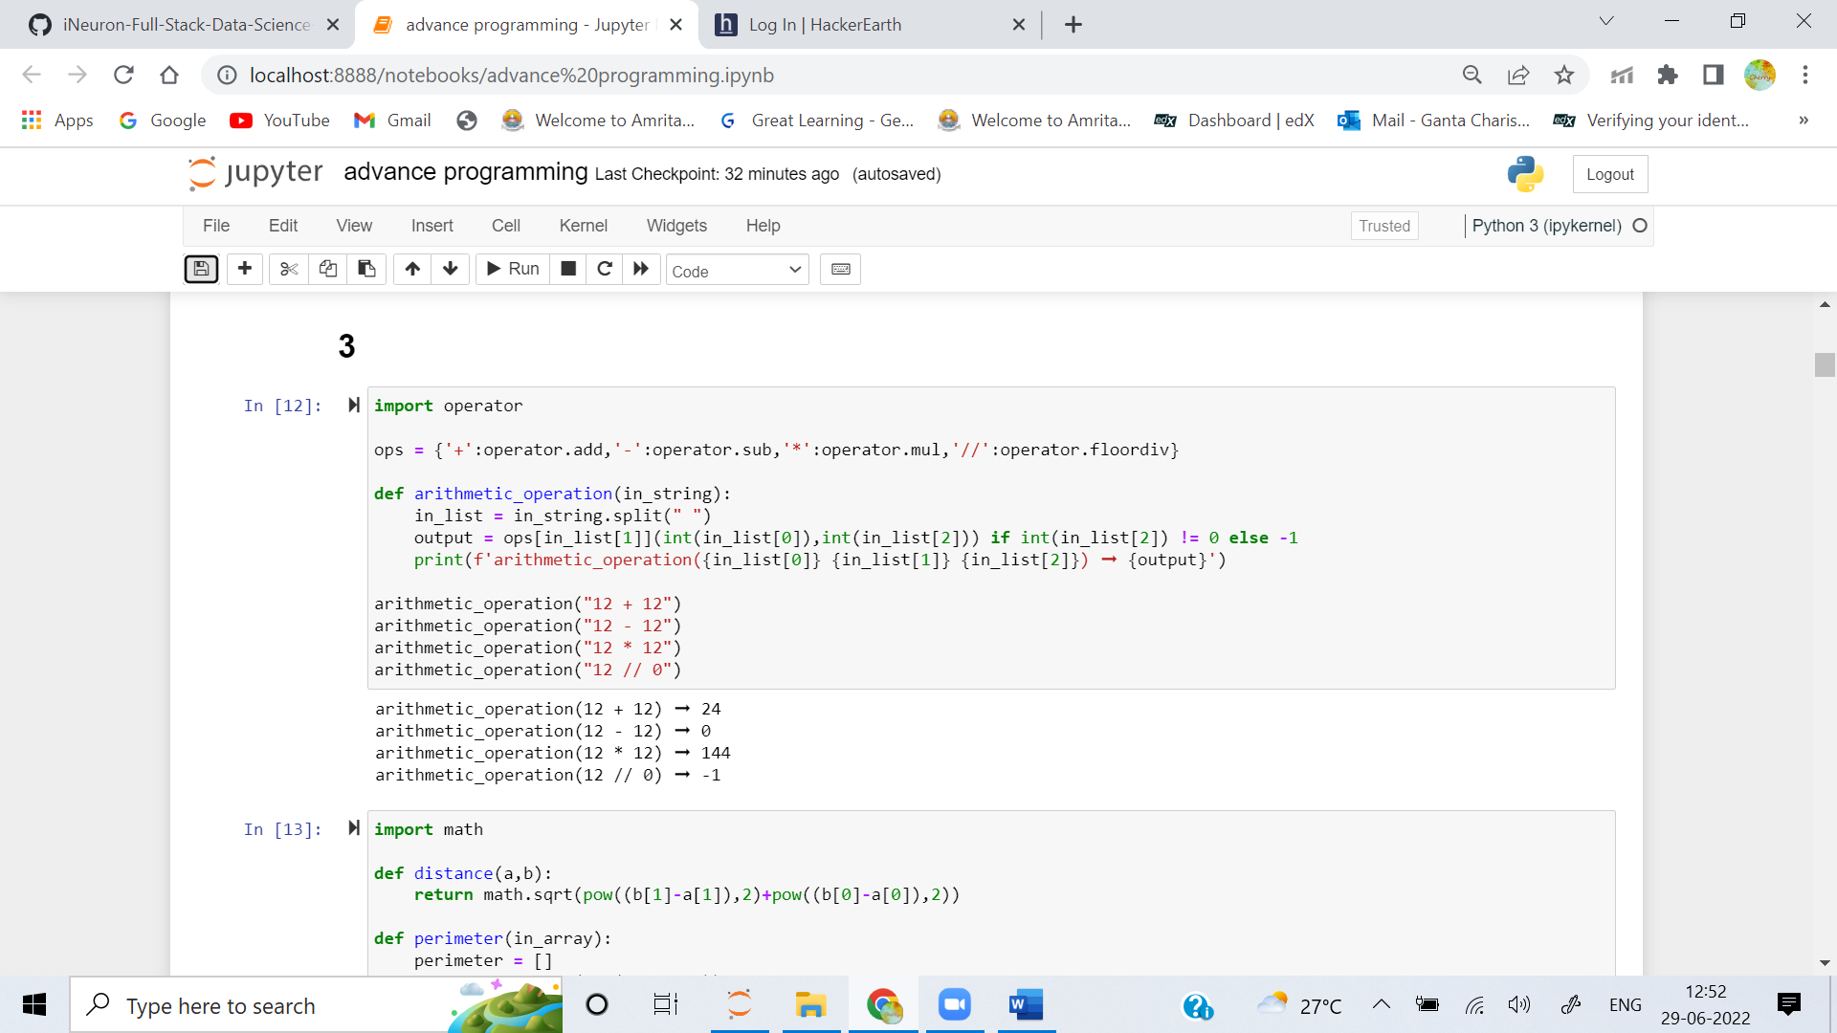

2. Write a function that takes the coordinates of three points in the form of a 2d array and returns the perimeter of the triangle. The given points are the vertices of a triangle on a two-dimensional plane.

**Examples**

perimeter( [ [15, 7], [5, 22], [11, 1] ] ) ➞ 47.08

perimeter( [ [0, 0], [0, 1], [1, 0] ] ) ➞ 3.42

perimeter( [ [-10, -10], [10, 10 ], [-10, 10] ] ) ➞ 68.28

**Ans:** 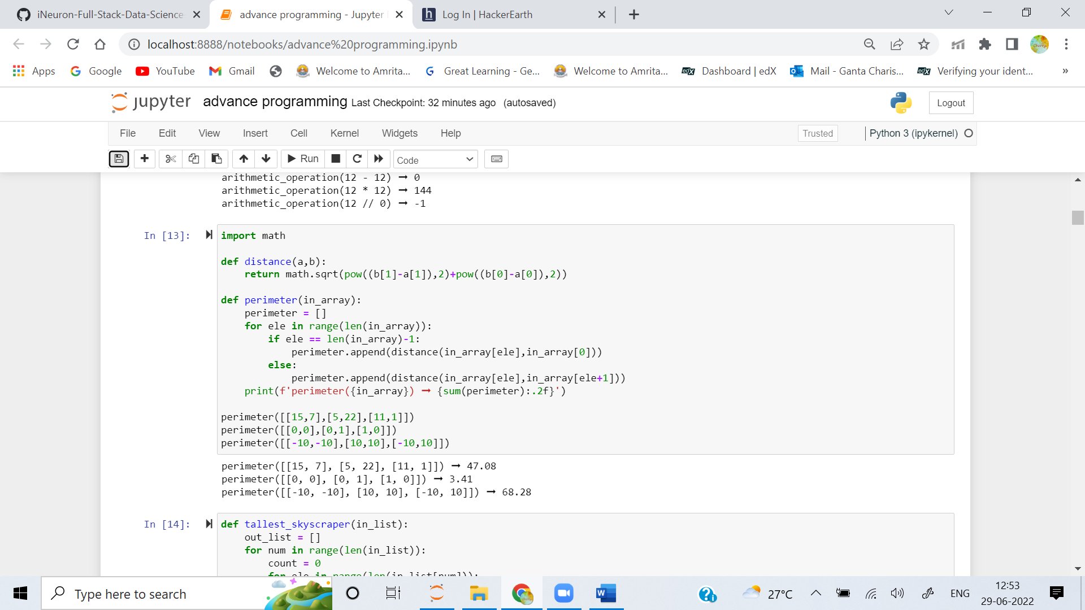

3. A city skyline can be represented as a 2-D list with 1s representing buildings. In the example below, the height of the tallest building is 4 (second-most right column).

[[0, 0, 0, 0, 0, 0],

[0, 0, 0, 0, 1, 0],

[0, 0, 1, 0, 1, 0],

[0, 1, 1, 1, 1, 0],

[1, 1, 1, 1, 1, 1]]

Create a function that takes a skyline (2-D list of 0's and 1's) and returns the height of the tallest skyscraper.

**Examples**

tallest_skyscraper([

[0, 0, 0, 0],

[0, 1, 0, 0],

[0, 1, 1, 0],

[1, 1, 1, 1]

]) ➞ 3

tallest_skyscraper([

[0, 1, 0, 0],

[0, 1, 0, 0],

[0, 1, 1, 0],

[1, 1, 1, 1]

]) ➞ 4

tallest_skyscraper([

[0, 0, 0, 0],

[0, 0, 0, 0],

[1, 1, 1, 0],

[1, 1, 1, 1]

]) ➞ 2

**Ans:** 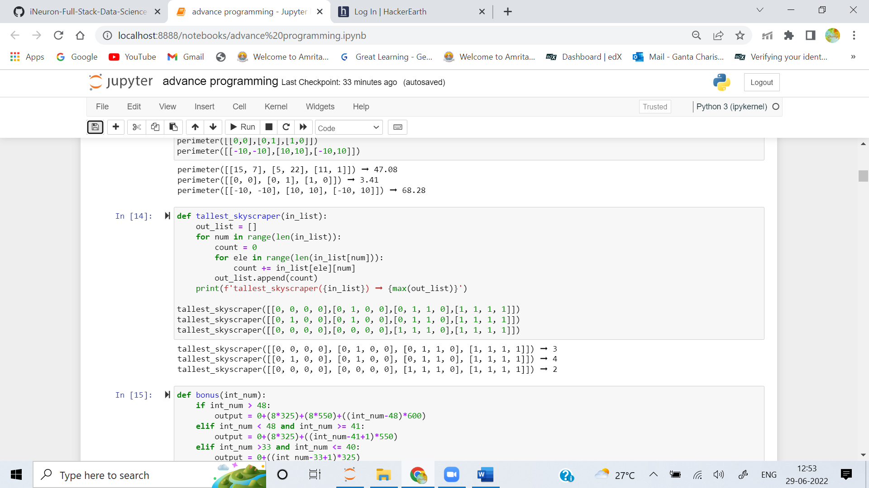

4. A financial institution provides professional services to banks and claims charges from the customers based on the number of man-days provided. Internally, it has set a scheme to motivate and reward staff to meet and exceed targeted billable utilization and revenues by paying a bonus for each day claimed from customers in excess of a threshold target.

This quarterly scheme is calculated with a threshold target of 32 days per quarter, and the incentive payment for each billable day in excess of such threshold target is shown as follows:

Days Bonus

0 to 32 days Zero

33 to 40 days SGD$325 per billable day

41 to 48 days SGD$550 per billable day

Greater than 48 days SGD$600 per billable day

Please note that incentive payment is calculated progressively. As an example, if an employee reached total billable days of 45 in a quarter, his/her incentive payment is computed as follows:

32*0 + 8*325 + 5*550 = 5350

Write a function to read the billable days of an employee and return the bonus he/she has obtained in that quarter.

**Examples**

bonus(15) ➞ 0

bonus(37) ➞ 1625

bonus(50) ➞ 8200

**Ans:** 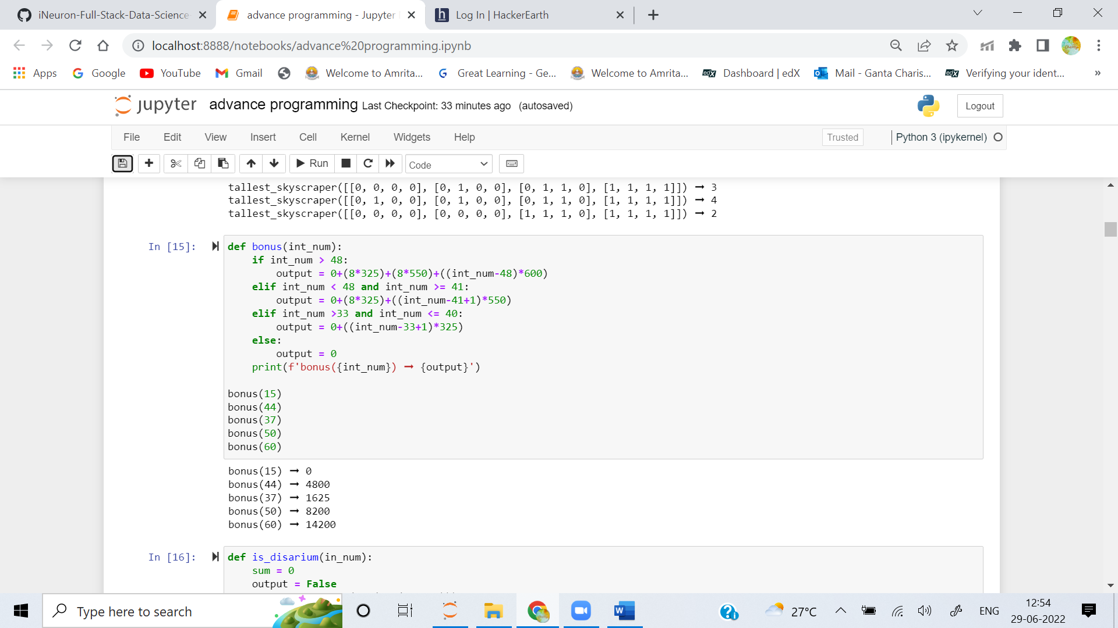

5. A number is said to be Disarium if the sum of its digits raised to their respective positions is the number itself.

Create a function that determines whether a number is a Disarium or not.

**Examples**

is_disarium(75) ➞ False

# 7^1 + 5^2 = 7 + 25 = 32

is_disarium(135) ➞ True

# 1^1 + 3^2 + 5^3 = 1 + 9 + 125 = 135

is_disarium(544) ➞ False

is_disarium(518) ➞ True

is_disarium(466) ➞ False

is_disarium(8) ➞ True

**Ans:** 